ADVANCE DEVOPS EXP-7

**MANORATH ITAL D15A/19**

**Aim:** To understand Static Analysis SAST process and learn to integrate Jenkins SAST to SonarQube/GitLab.

**Step-1:** Open up Jenkins Dashboard on localhost, port 8080 or whichever port it is at for you.

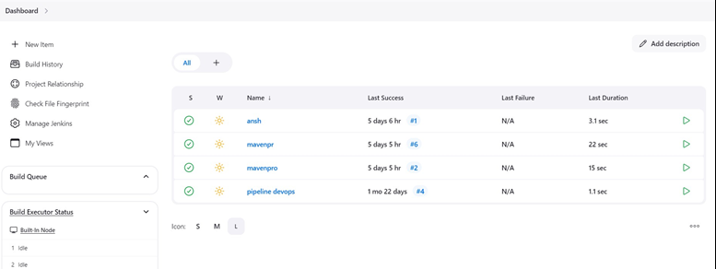

**Step-2:** Run SonarQube in a Docker container using this command :- a]docker -v b] docker run -d --name sonarqube -e

SONAR_ES_BOOTSTRAP_CHECKS_DISABLE=true -p 9000:9000 sonarqube:latest

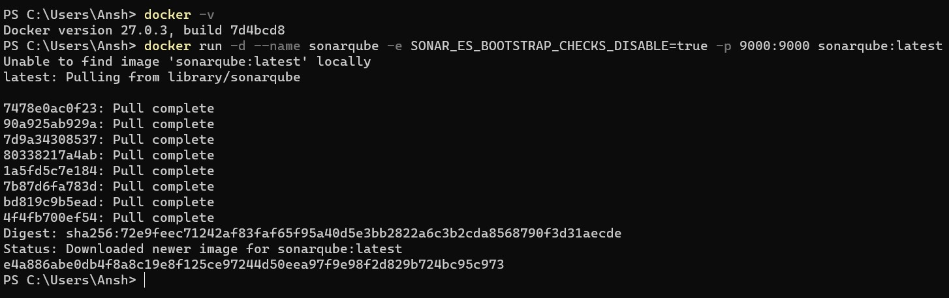

**Step-3:** Once the container is up and running, you can check the status of SonarQube at localhost port 9000. The login id is “admin” and the password is also “admin”.

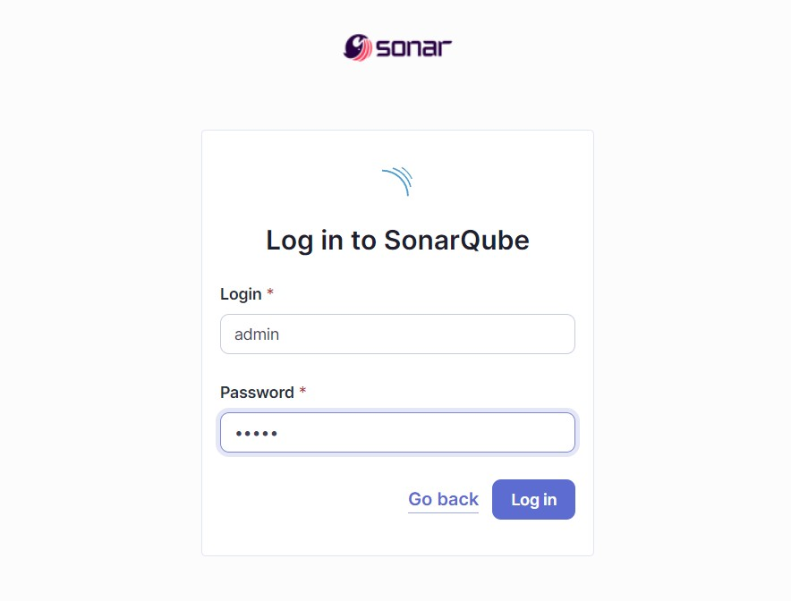

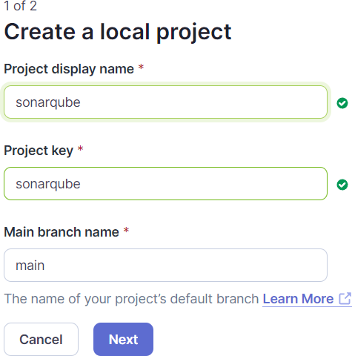**Step-4:** Create a local project in SonarQube with the name sonarqube

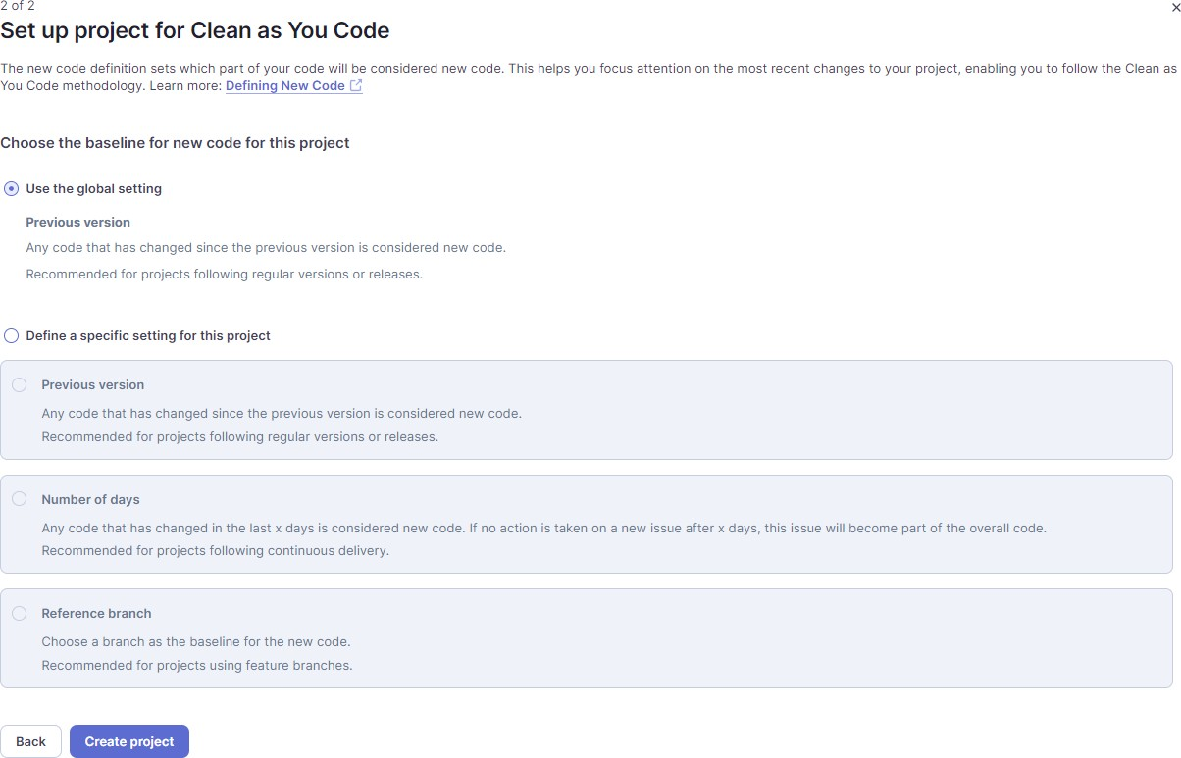

**Step-5:** Setup the project and come back to Jenkins Dashboard. Go to Manage Jenkins

→ Plugins and search for SonarQube Scanner in Available Plugins and install it.

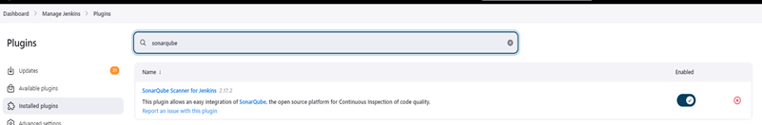

**Step-6:** Under ‘Manage Jenkins → System’, look for SonarQube Servers and enter these details. Name : sonarqube, Server URL : http://localhost:9000

**Step-7:** Search for SonarQube Scanner under Global Tool Configuration. Choose the latest configuration and choose Install automatically. Manage Jeknins → Tools → SonarQube Scanner Installation.

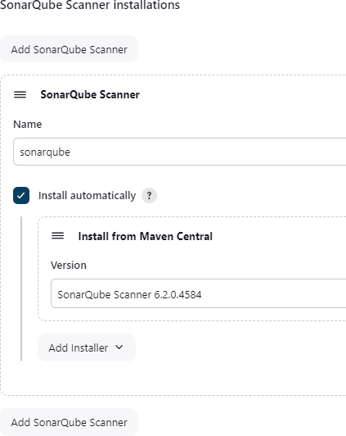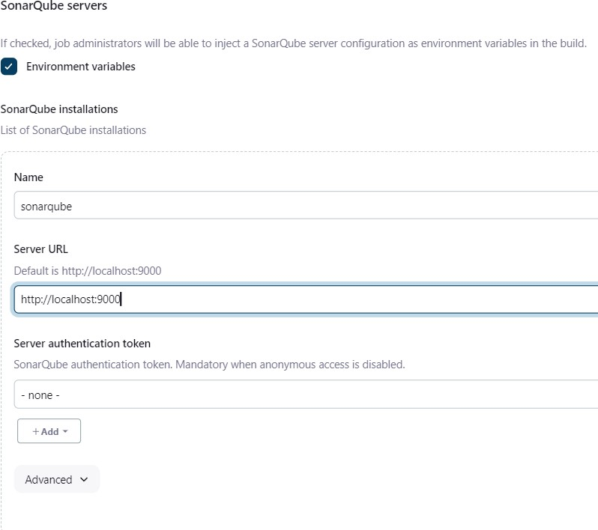

**Step-8:** After the configuration, create a New Item in Jenkins, choose a freestyle project named sonarqube.

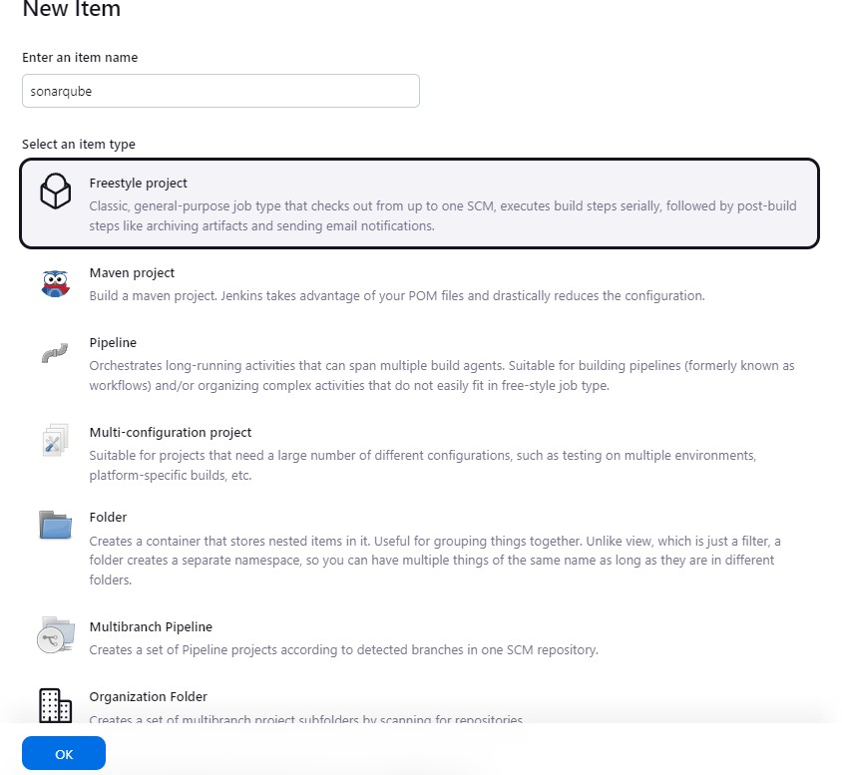

**Step-9:** Choose this GitHub repository in Source Code Management. <https://github.com/shazforiot/MSBuild_firstproject.git> . It is a sample hello-world project with no vulnerabilities and issues, just to test the integration.

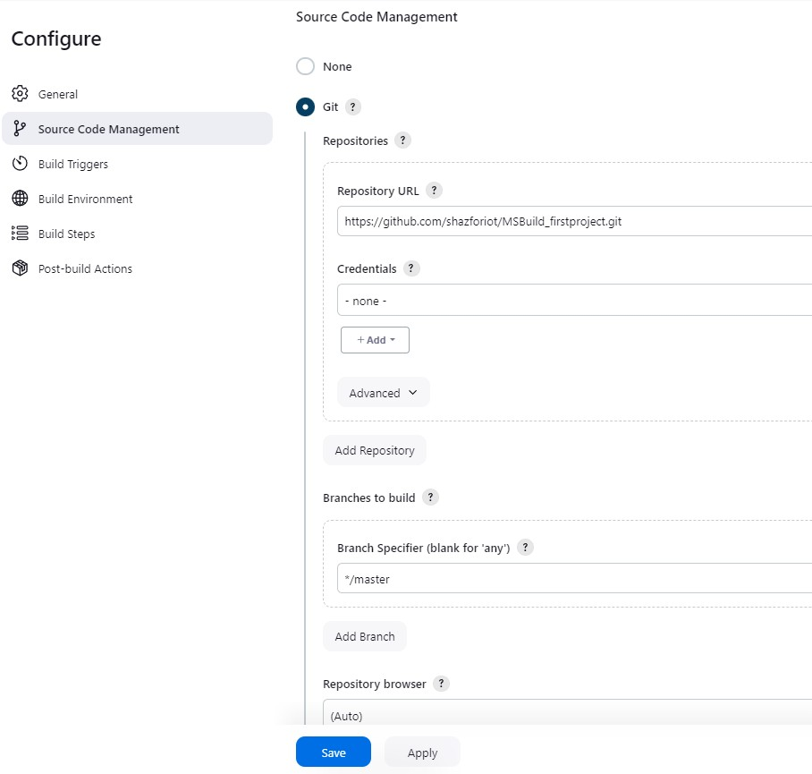

**Step-10:** Under Build-> Execute SonarQube Scanner, enter these Analysis Properties. Mention the SonarQube Project Key, Login, Password, Source path and Host URL.

sonar.projectKey=sonarqube sonar.login=admin sonar.password=ansh sonar.sources=. sonar.host.url=http://localhost:9000

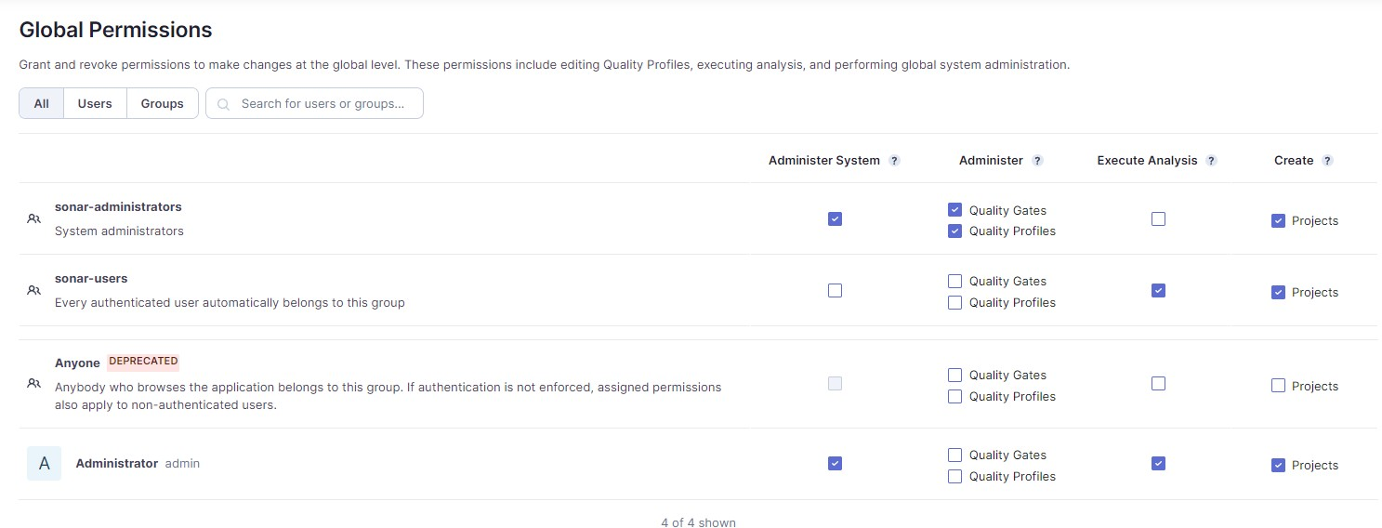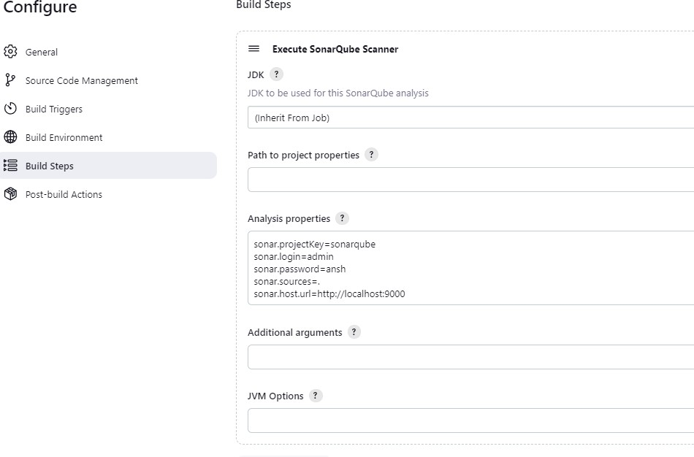

**Step-11:** Go to http://localhost:9000/admin/permissions and allow Execute Permissions to the Admin user.

**Step-12:** Run The Build and check the console output.

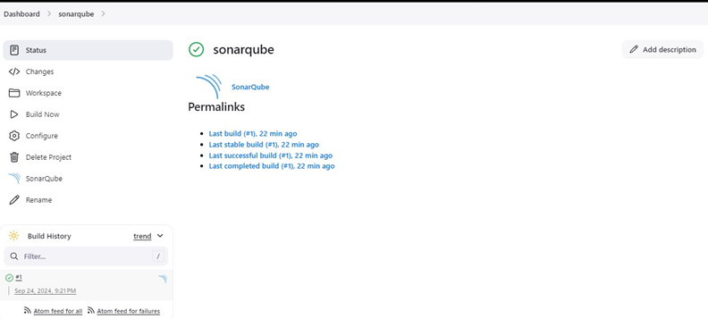

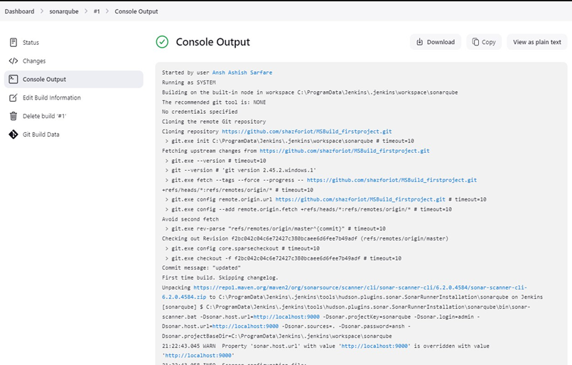

**Step-13:** Once the build is complete, check the project in SonarQube.

